**​Body Mapping of Emotions**

It is not uncommon to be overcome by a particular bodily sensation when a certain emotion washes over us. When we feel depressed, we might experience heaviness within the body, or it might feel as if energy flow within us is stagnant. When we are angry, we may feel some tightness in the forehead or increased activity in the head region in general. Whatever the pairing, it turns out that each emotion seems to appear across cultures.

Research conducted by [Finnish scientists](https://www.fastcompany.com/3024327/an-atlas-of-the-human-body-that-maps-where-we-feel-emotions) sought to discover how bodily sensations pair with various emotions. Over 700 volunteers participated in the study that linked various basic and complex mindfulness of emotions with felt increasing and decreasing activity within various bodily regions. The result was a heat map that provides insight as to where different emotions manifest within the body. The results were congruent between West European and East Asian samples, suggesting that the link between emotions and the body is a universal phenomenon.

Understanding that emotions have a direct effect on the sensations we perceive within the body can help us to become more mindful of the intimate link between body and emotion. It provokes the question: can we become more aware of the very raw, physical manifestation associated with a rising emotion, rather than becoming consumed by the story that led to it?

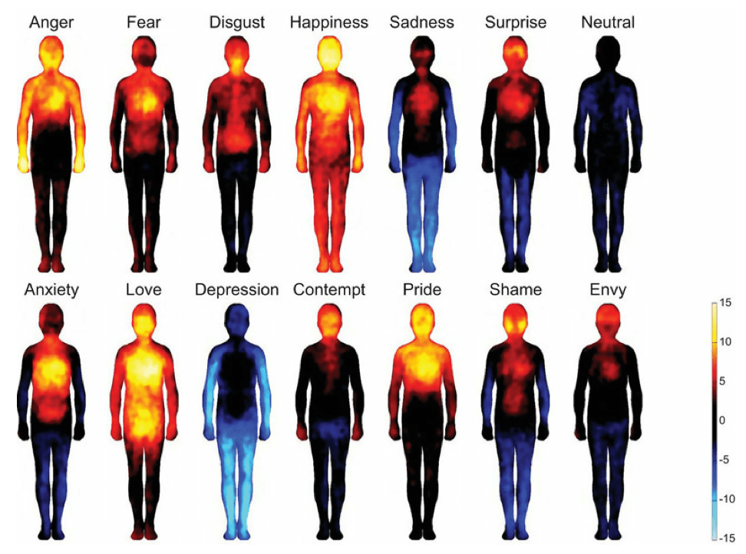

## ****Opening to Emotions Mindfully****

Mindfulness of emotions are part of the human experience. In and of themselves they are neither good nor bad, so becoming mindful of them does not have to entail condemnation, judgment, or suppression; in fact, mindful awareness of our emotions is quite the opposite. Opening to our emotions mindfully is possible only from a place of unconditional love. It is a continual practice that offers us a new vantage point from which to relate differently to these energetic flows.  
  
When mindfulness of emotions arise consider these four ways to open up to them mindfully.

### **1. Turn towards the emotion.**

There is a common tendency to move away from difficult emotions when they arise. While this may have once served as an effective defense mechanism, we can help ourselves to move through the emotion more effectively by turning towards it. By [taking a few deep breaths](https://mindfulnessexercises.com/6-mindful-breathing-exercises/) and gently opening ourselves to whatever is present, we are able to transition through our emotional landscape with greater understanding and acceptance. The key here is to opening from the heart and staying open to whatever arises.

### **2. Create space by identifying the emotion(s) – without judgment.**

It is easy to become caught up in the story associated with the emotion – why we feel it, who is responsible, and how it could have been avoided. While there is a time and place for this inquiry, it can be useful to detach from the mindfulness of emotions when we are in the heat of them. We can practice this by becoming aware of what exactly is moving through us. Rather than saying to ourselves, “I am angry,” which often leads to, “because…” we can instead simply notice what is present. Simply witness ‘anger’, ‘grief’, ‘sadness’, or whatever is the case as though it were a separate entity. Open to this energetic presence with compassion and curiosity, noticing if the mind intervenes with judgment. Come back to an open heart.

### **3. Feel into any bodily sensations that are present.**

When we become caught up in mindfulness of emotions, [we can open our awareness to the entire body.](https://mindfulnessexercises.com/downloads/working-with-emotions-in-your-body/) What do we notice? Where do we sense increased or decreased activity? Even numbness can be observed. Feeling into the way the emotion presents itself in the body can help us to create some sort of distance in-between ourselves and the energy moving through us. As we practice creating this distance, strengthening our awareness of it, we come to realize that our emotions are just a happening that can be witnessed from a quieter, more peaceful place.

### **4. Become aware of the impermanence of this state.**

Feelings, thoughts, and sensations all come and go; such is the nature of life. When mindfulness of emotions rise, we can heighten our awareness of the transitory nature of our experience. Through this opening to the flow of our emotions, we become less consumed by them. We start to loosen our grip on the beliefs we hold about them. We come to realize that we are not, in fact, our emotions; and through this realization we find strength to journey through the storm in our sails.